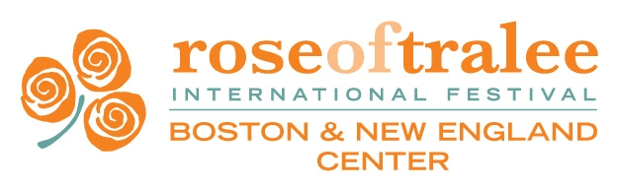

Entrant Questionnaire 2017

Please complete the following questionnaire as accurately and completely as possible. This should be typed or neatly handwritten and signed. The information will be used as part of the Press Information Pack and for the Judges.

Regional Selection: Boston and New England Rose of Tralee

PERSONAL DETAILS

Name in full: Name normally used:

Address:

Date of birth:

Contact Number - Mobile:

Email (if you do not have a personal email address, please supply an alternative one where we can reach you):

EMPLOYMENT

Current occupation:

Employer:

Do you plan this as a full time career (please elaborate)?

Other career(s) you would like to pursue:

EDUCATION

High school:

Other secondary school:

College:

Major: Minor:

Degree Achieved:

Academic achievements:

Special achievements/favorite subjects:

Achievements:

FAMILY ANCESTRY

Father’s name: Place of birth:

Mother’s name: Place of birth:

Brothers and Sisters (please list names and ages):

*If you or your parents are not Irish born, please let us know the background on your Irish ancestry (state relationship, name, county and nearest town):

Do you or members of your family have any active involvement with Irish organizations or clubs?

LEISURE ACTIVITIES/SPECIAL INTERESTS

Please list your hobbies, leisure activities, sports interests or if you belong to a group or club. Include any special achievements.

Do you play a musical instrument, sing or dance, participate in sports, belong to group or club activities, perform on stage?

Please list your likes and dislikes:

Likes:

Dislikes:

Who are your favorite entertainers/performer

What do you most like about where you live, work or go to school?

Have you previously entered any events similar to the Rose of Tralee? Give details.
Have you visited Ireland before? If yes, where did you visit and when?

Is there any personality you would like to meet and why?

GENERAL

Please describe what it would mean to you if you were to be selected as the Boston New England Rose of Tralee.

How did you find out about the Rose of Tralee Festival?

Describe your own special characteristics and traits, your special strengths and talents:

What are your personal goals and ambitions?

What personal quality are you most proud of?

Where do you see yourself five years from now?

Thank you for completing this questionnaire. Remember that it will be used to compile press releases and other publicity information, so it is important that it is completed as accurately and comprehensively as possible.

If you have any questions regarding any of the information required please contact the Boston and New England Rose Committee at BostonRoseCommittee@gmail.com.

Name: (please print) ________________________________

Signature: _______________________________________ Date:_________________

Please email this completed application including headshot with plain background (in JPEG format) to the BostonRoseCommitee@gmail.com email address and please mail a $150 check made out to Boston and New England Rose Center (no cash).

Boston and New England Rose Center
8 Argonne Road
Billerica, MA 01821

Thank you and we are very excited to receive an application from you! Good luck!

